**Step 1:**

Proc.h



Proc.c





**Step 2:**

Syscall.h



Syscall.c





Sysproc.c

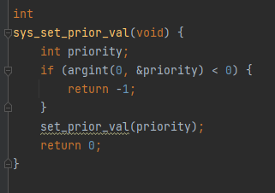

Proc.c

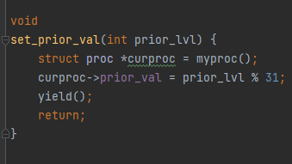

Usys.s



User.h



Defs.h



**Step 3:**

Proc.c

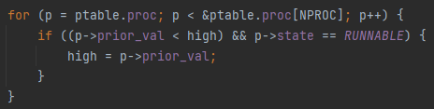

**Aging:**

Proc.c

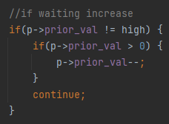





**Turnaround and Waiting time:**

proc.h



Proc.c (allocproc)



Exec.c



Proc.c (fork)



Proc.c(exit)

